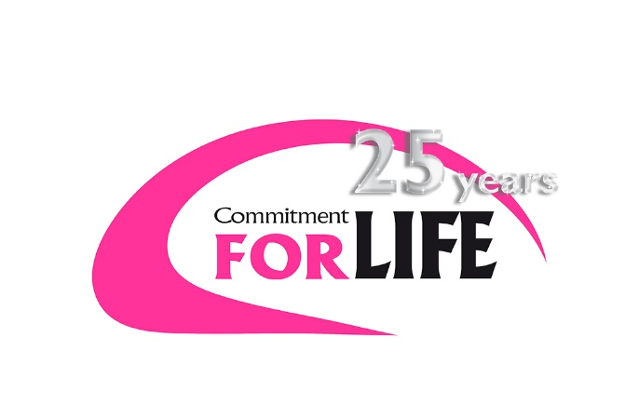
Magazine article
Please adapt for your own use

Commitment changes lives - Commitment for Life remembers 25 years of being part of the mission of the United Reformed Church.

25 years is a long time to be in a partnership. Can you remember what you were doing in 1992?
- The average House Price £68,634 and inflation Rate was 3.7%
- Bosnia Herzegovina declares independence and a 3 year war followed between Muslims, Serbs and Croats prompting UN intervention
- Signing of the Maastricht treaty on 7th February which founded the European Union
- Euro Disney opens in France
- Bill Clinton becomes U.S. president
- Rioting by local youth breaks out across cities including Bristol
- US refuses to sign The UN convention on Climate Change and Biological Diversity in Rio de Janeiro
- Fire damages a major part of Windsor Castle and a number of important works of art, books and furniture are lost
- The Summer Olympics are held in Barcelona, Spain
- Rioting breaks out in Los Angeles following the acquittal of four white police officers accused of beating black motorist Rodney King.
- Violence flares in Germany against Immigrants blaming them for economic problems.
Favourite films included: A Few Good Men, Sister Act, The Bodyguard
And on the television you might have been watching: One Foot in the Grave, The Crystal Maze, Casualty or Inspector Morse
AND The General Assembly of the United Reformed Church, in York, commended Commitment for Life to churches as a way of putting their faith into action. Having previously been known as The 1% Appeal, which encouraged Christians to give 1% of their disposable income to aid development, it would now tell stories of how the money was being used and help congregations understand about the structures that keep people poor and how to bring justice for all.
Today, Commitment for Life is firmly embedded in the mission of the church and has raised millions of pounds to help people rise out of poverty and live fulfilled lives. It has also changed the lives of those who have visited partners or heard them speak in their churches. Rev John Marsh has shared a memory from his trip with Commitment for Life to Zimbabwe in 2011.
“The kindness of her neighbours, and the visits by the nurse from the Clinic, supported by funds from Christian Aid and Commitment for Life, were Maureen’s only dying comfort and solace. “Thank you for coming to see me”, she said.
These utterly poor people have nothing. So they make something out of nothing. It’s what they do.
If, in the years since our visit, all had become well for Zimbabwe and its people, we could rejoice that the need was no longer there. Sadly, but truly, little has changed for the better and Commitment for Life’s active participation with Christian Aid is urgently necessary going forward.
Where there is nothing, we need to continue to do, and be, something gracious and miraculous for God and for God’s people.”
‘So you see, faith by itself isn’t enough.’(James 2:17) James wrote his epistle not with the intention of telling people how to become a Christian but rather how to act like one. James sees faith and works as integral to each other.
Thank you for being a Commitment for Life Church and raising £ (add in last year’s amount) last year. Thank you for engaging with issues, retelling stories and praying for partners. Your gifts have made a real difference over the last 25 years but there is still so much more to do.

Linda Mead: Programme Co ordinator
(Name of link person): Link person for (Church name)

