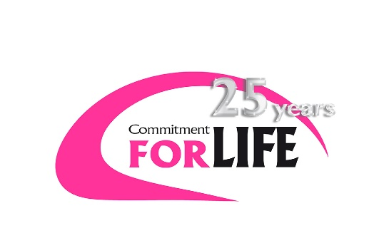
Israel and the occupied Palestinian territory

Women from Beit Furiq

The occupied West Bank is a challenging environment in which to make a living, particularly for women. Local industry is subjected to movement and trade restrictions, limited technical imports and natural resources, and there is little physical space to develop. Farmers and producers have few opportunities to access vital agricultural services and market information to increase production.
Area C of the West Bank is under full Israeli civil administration and security control. People there mostly rely on agriculture to make a living, but face numerous obstacles, and Palestinians in the region are becoming increasingly marginalised.
Women are particularly affected. Many are prevented from working due to social and cultural restrictions, which have also stopped them gaining the necessary skills and support needed to enter employment or set up their own business.
Christian Aid’s local partner the YMCA is helping transform the lives of people, particularly women, in Area C in a number of different ways. With the support of Commitment for Life, the YMCA’s Women’s Training Program is giving women greater opportunities to earn a secure living. They are also working with existing agricultural cooperatives, training them in environmentally sustainable methods, as well as building their skills and capacity to reach more people with their products. Earning a living for life
The YMCA team always starts by working with local communities to carry out a Participatory Vulnerability and Capacity Assessment (PVCA). This helps identify the risks and barriers people have faced in the past, and any activities that could help them overcome those barriers.
Following this assessment, 50 women in the villages of Jub-Al-Deeb and Al-Oqban attended training on agricultural production, food processing, animal husbandry, family health and small project management. Seeds and seedlings were also distributed to the trainees. These training sessions give women the confidence and skills to earn a sustainable living, allowing them to contribute to local economic development and increase their resilience under occupation.
In the Deir Balout village, the YMCA is working with a cooperative to increase its income through promoting, marketing and distributing pickled cucumbers. The cucumbers were bought from women farmers, and 31 cooperative members, including women, were trained in pickling. With the YMCA’s support, the cooperative has seen an increase in sales to such a level that it has found it hard to meet demand. In addition, women farmers received help to market 600 jars of their pickles through the cooperative, helping them reach more customers and grow their business.
The YMCA is working with another cooperative in the village of Beit Duqqu to help it produce an environmentally sustainable, quality product, reach new customers and improve sales. Cooperative members have been learning a new technique, developed and tested by the local Adel Fair Trade Non Profit Corporation, which reduces the use of chemical fertilisers, protecting the environment and producing fruits and vegetables that are free of artificial preservatives and chemicals.
By partnering with Adel Fair Trade Non Profit Corporation, the cooperative is not only gaining from its expertise in this field, but also its market knowledge and access. According to Jihad Abddo, head of marketing at Adel: ‘There is increasing interest in local products. The demand exceeds the supply, especially for fresh fruits and vegetables.

July 2017/18 Mini magazine

